

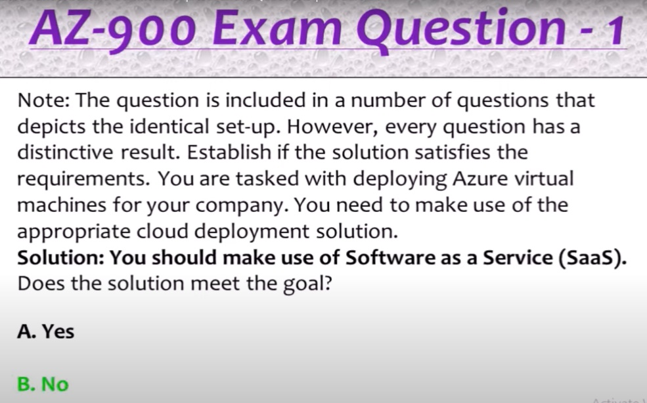

Because azue virtual machine is Under IAAS

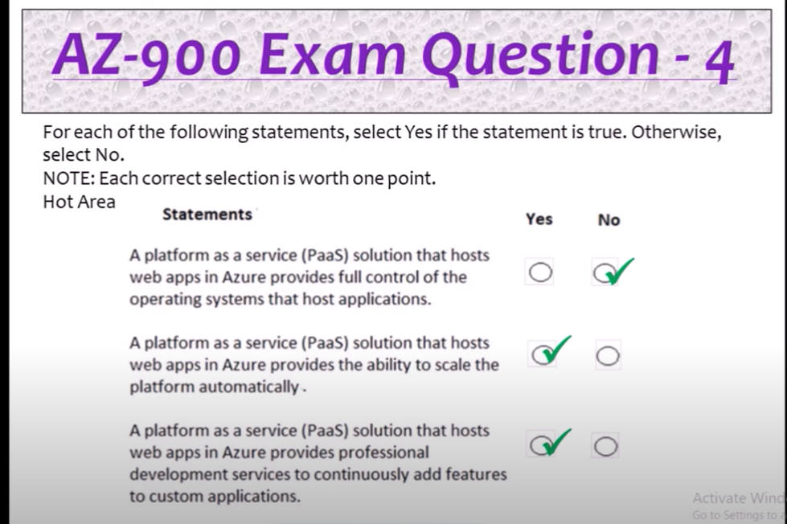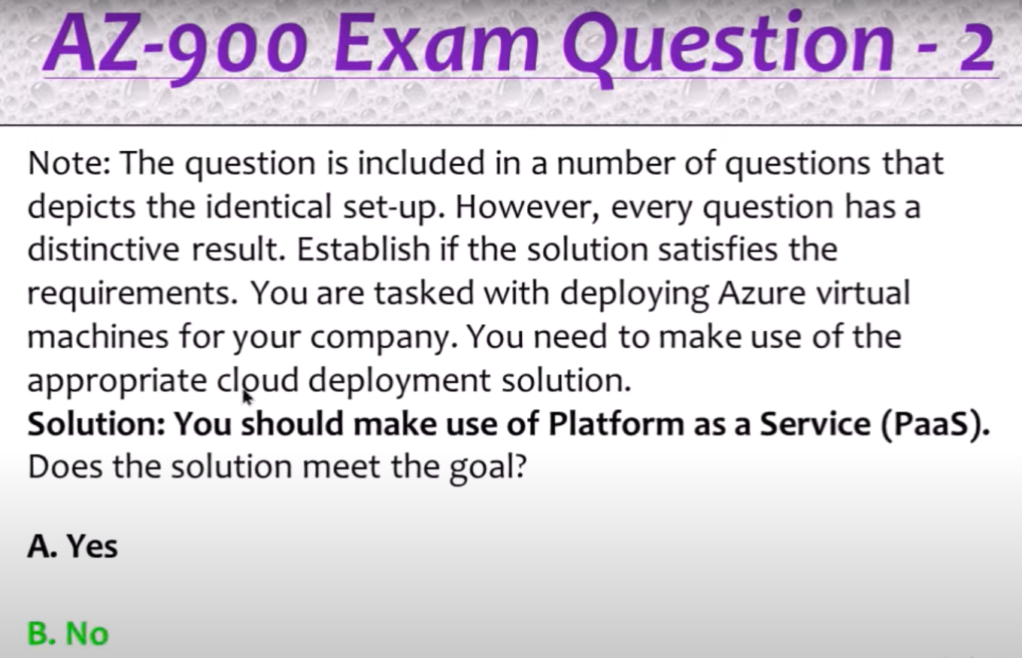   
Because azue virtual machine is Under IAAS

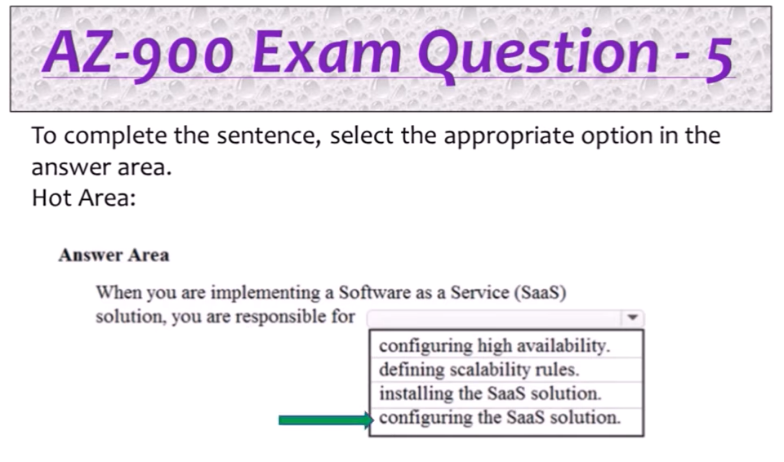 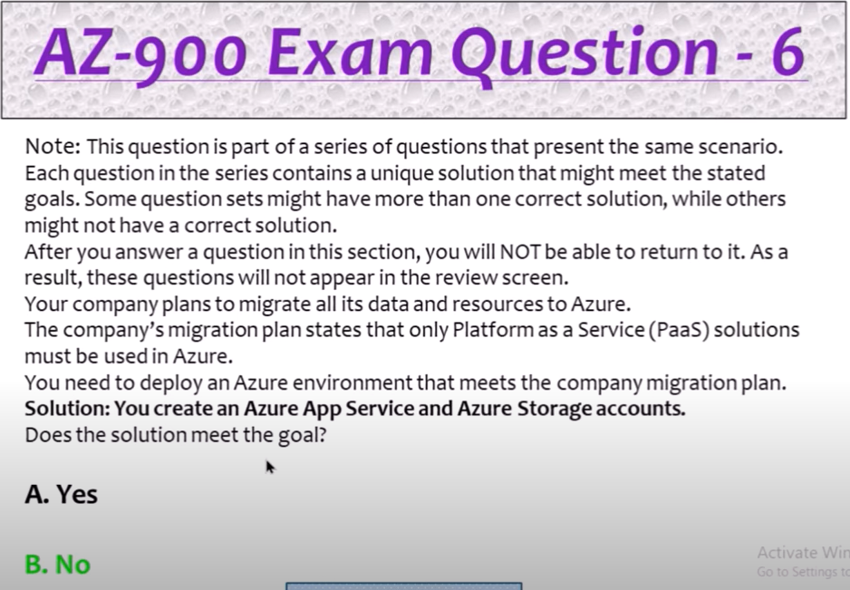 NOTE:

Azure app is under PAAS

Azure Stroge accounts is under IAAS

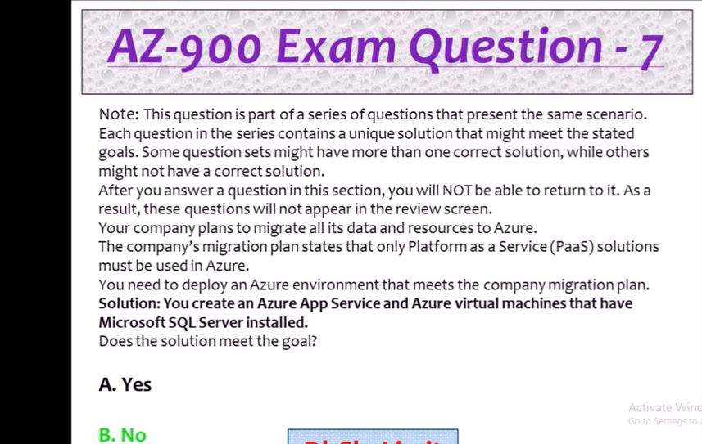

Azure virtual machine is under in IAAS



Azure virtual machine -IAAS

Azure SQL database -PAAS

Azure storage account -IAAS

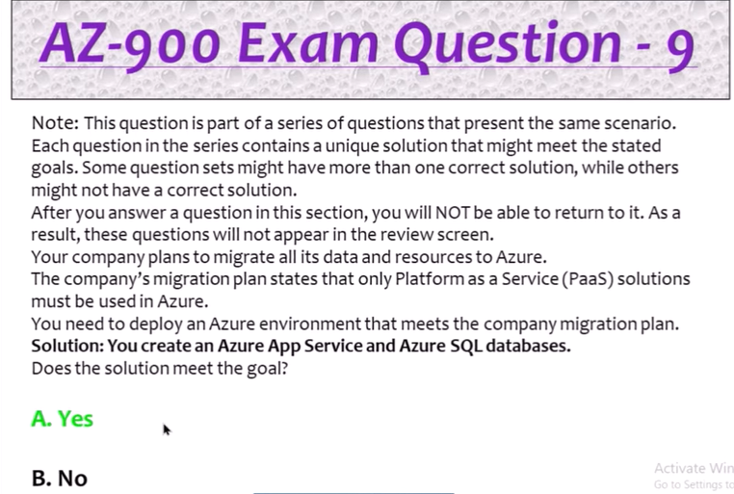

Azure app Service -PAAS  
Azure Sql Databases-PAAS

